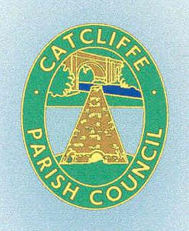
CATCLIFFE PARISH COUNCIL
Catcliffe Memorial Hall Old School Lane
Catcliffe Rotherham S60 5SP

APPLICATION FOR THE HIRE OF THE MEMORIAL HALL

Completed forms should be returned to either:
Catcliffe Parish Council, Old School Lane, Catcliffe Rotherham S60 5SP Or email to: clerk@catcliffepc.com

HIRERS NAME
HIRERS ADDRESS (INCLUDING POSTCODE)
HIRER OVER AGE OF 21 YEARS | YES/NO
TELEPHONE NUMBER
DATE OF HIRE
TIMES FOR HIRE | Arrive at Hall: Leave Hall:
PURPOSE OF HIRE
(e.g. birthday party)
NUMBER OF PEOPLE ATTENDING
IS ALCOHOL TO BE CONSUMED AT THE EVENT | YES/NO
PLEASE SIGN TO SHOW YOU HAVE RECEIVED AND ACCEPT THE TERMS OF USE FOR THE
MEMORIAL HALL

